# OOD Assignment Preliminary Design: Logo/Turtle Emulation

## Group Members

Oli Davis (od00013), Craig Lord (cl00123), James Sinclair (js00181)

## Aim

To write a program using the C++ language that will read in a file containing a list of commands, which will then be used to control the motion of the cursor to create the corresponding line drawing.

## Operation

The program will accept a command line argument for the input file. A “ParseInput” object will then be instantiated and the “PopulateCommandList” member function will be passed a pointer to the input file.

This function then passes the input file, first checking each command is valid and if so instantiating the respective instruction object. Each instruction object is created with its size member variable being initialized as the parameter for that command. For the commands RIGHT and LEFT the rotate object will be instantiated with a positive or negative size variable respectively. In the case of the repeat object a sub-list will also be created containing the repeated instructions.

The “ExecuteCommand” function simply iterates through the command list calling the print function of each object, which renders the design to the screen.

### Class Diagram

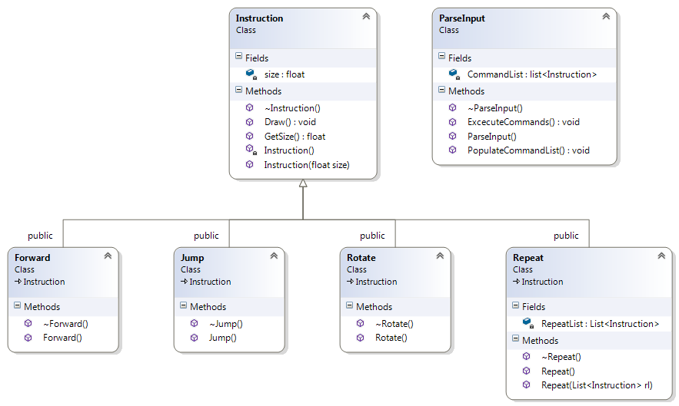

## Design

Our design will handle errors in the file read stage by halting the program and informing the user of the erroneous command. There will also be basic error checking, for example: out of memory.

With regards to memory management the list objects will be created dynamically and all constructors and destructors will be explicitly implemented to ensure no memory leaks.

The use of the virtual print function in the instruction object greatly simplifies the drawing to the screen due to the use of run-time polymorphism. Also the individual commands are all derived from an individual base instruction class.